Assignment – 2

• Connect to Store Sales Data….

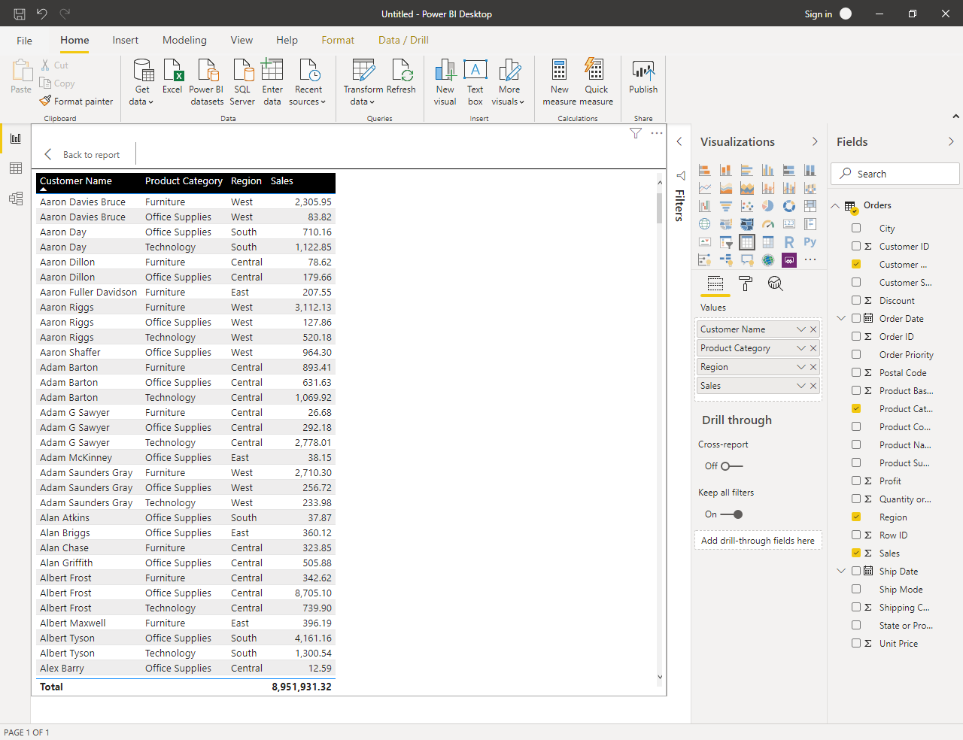

• Create a line and clustered column chart showing sales and discount as per the state or province

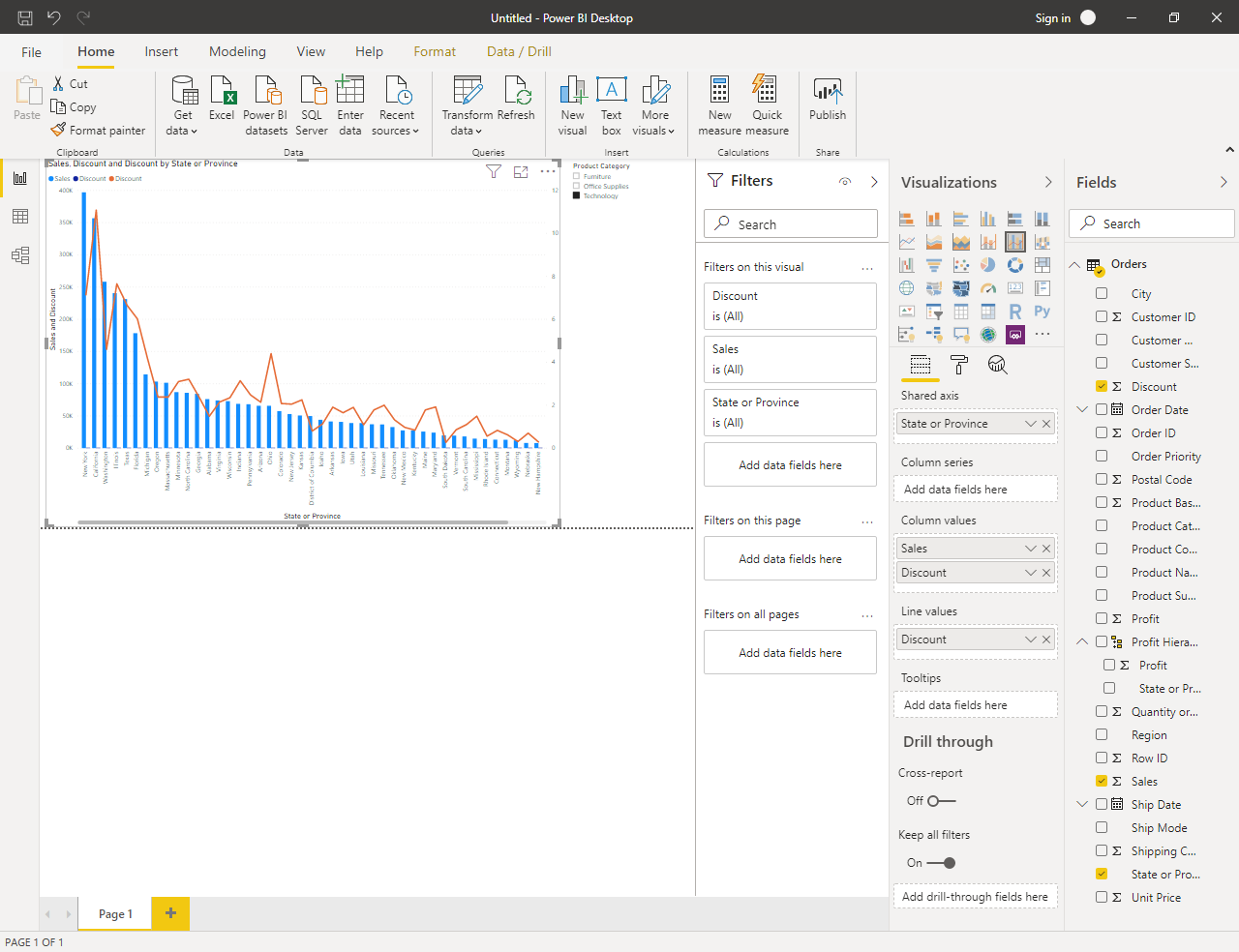

New York State has the highest sales in terms of Technology Product Category

• Create a Donut Chart showing sales in terms of product category

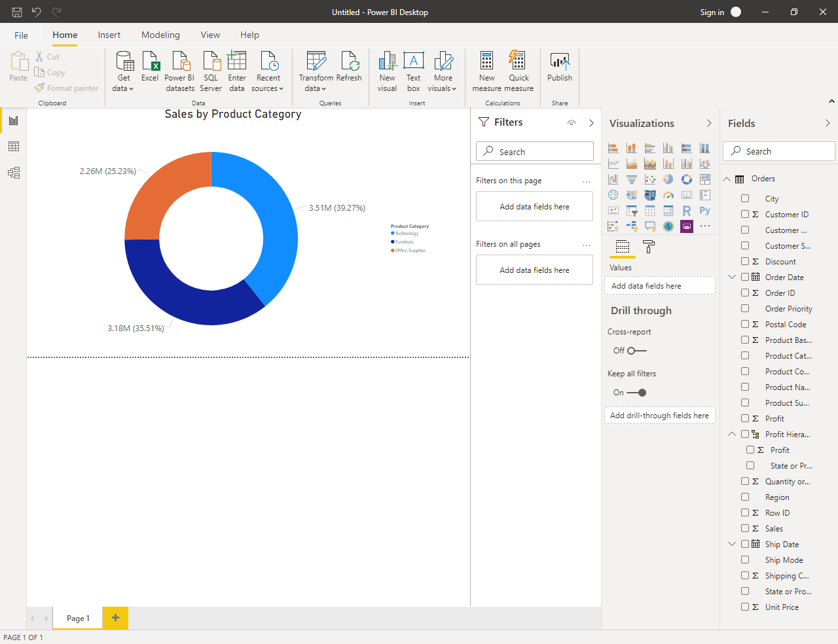

• Create a Slicer and show regions in dropdown for above three visuals

